1. **Overall Project**

Cosmetic and skincare spending among Hispanic women, which historically was lower due to underrepresentation in the beauty industry and lack of inclusive products, has increased significantly in recent years. This shift is driven by greater cultural visibility, targeted marketing, and improved economic access. As someone passionate about representation in wellness and beauty spaces, I seek to support Hispanic women in underserved areas by providing access to affordable and culturally relevant personal care products.

As my user group, I will focus on Hispanic women aged 18–44, as this is the demographic currently showing one of the fastest-growing interests in cosmetics, skincare, and wellness. I will use spending on Cosmetics/Perfume/Bath/Skincare/Nail Products to identify high-demand areas. Using ArcGIS Pro, I will identify states, counties, zip codes, and ultimately block groups (neighborhoods) with these focal characteristics.

Then, I plan to coordinate outreach programs—such as discounted product bundles or skincare pop-up events, for all residents in those areas, regardless of age or ethnicity, while ensuring high exposure to my primary user group through community-based screening and targeted communication strategies.

1. **Demographic User Group:**

The Default Base here is HISPPOP_CY, meaning the Hispanic Population in Current Year. This is an unsuitable BASE for my analysis; it shows % of Hispanic Females aged 15–44 compared only to the total Hispanic population. But I need the % of Hispanic Females aged 15–44 compared to the Total Population to understand the true prevalence of this user group within a geographic area.

Thus, here, I ask for the raw numbers or counts of Hispanic Females aged 15–44, and later on I will hand calculate their percent of the total population. This will allow me to more accurately identify areas where outreach programs around affordable cosmetics and skincare products will have the greatest impact.

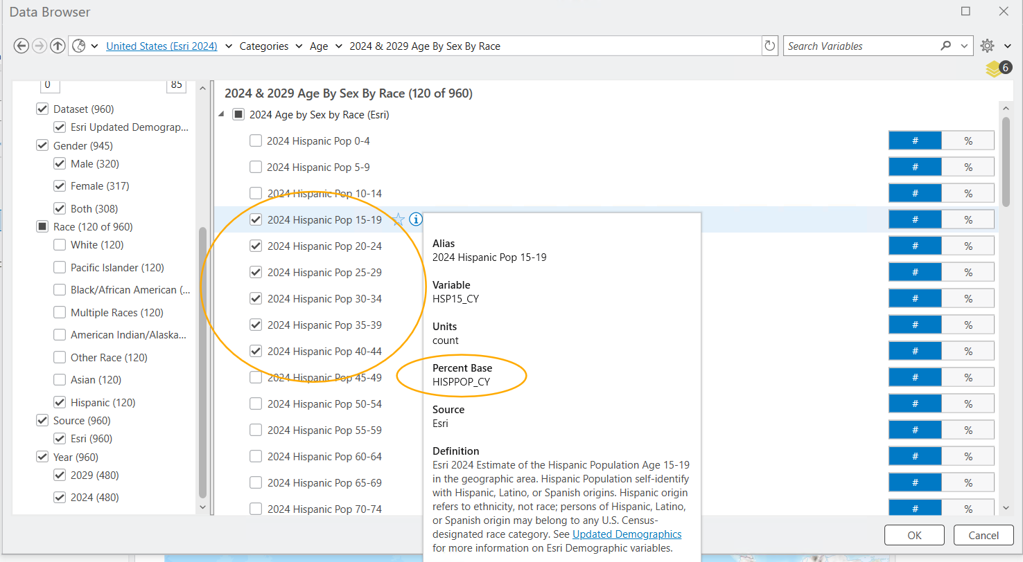

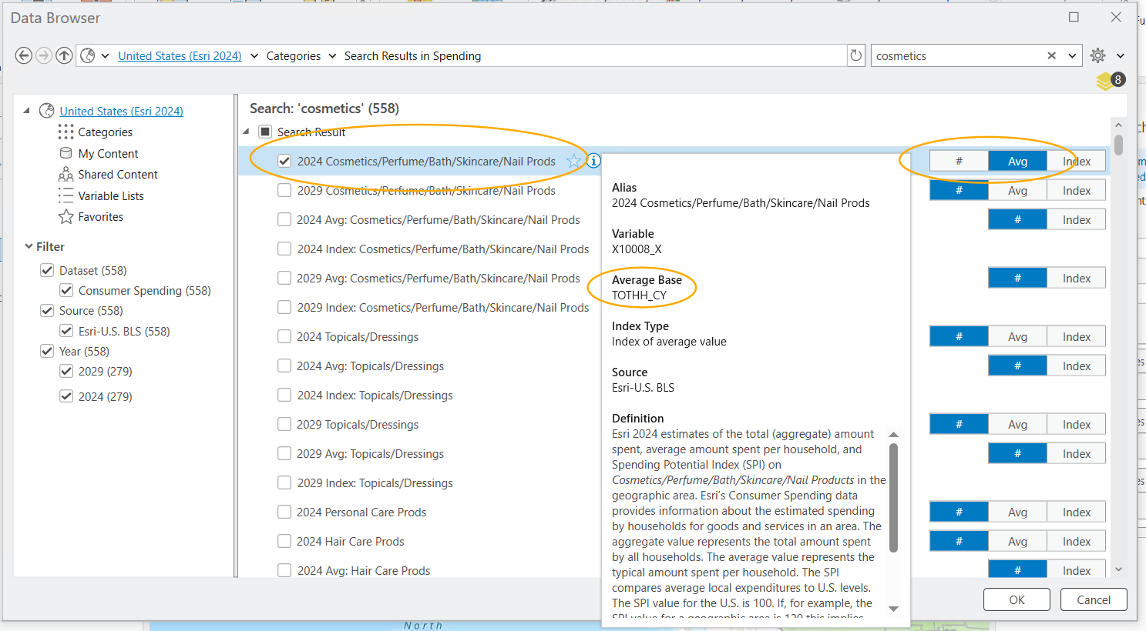

1. **User Group Count:**

My formula for the demographic user group count is below. I sum up the counts of Hispanic females for ages 15–44, in 5-year increments.

This gives me the total raw count of Hispanic females in the 15–44 age range, which I will later use to calculate their percentage of the total population in each area.

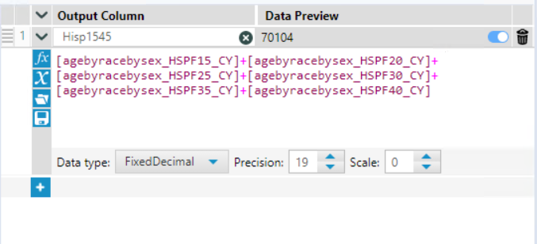

1. **User Group %:**

My formula for the demographic user group % is below. I use the count of Hispanic females aged 15–44, divided by pop2024. This gives me the % of Hispanic females aged 15–44 relative to the total population.

This helps me understand the true prevalence of my target user group in each geography I’m analyzing.

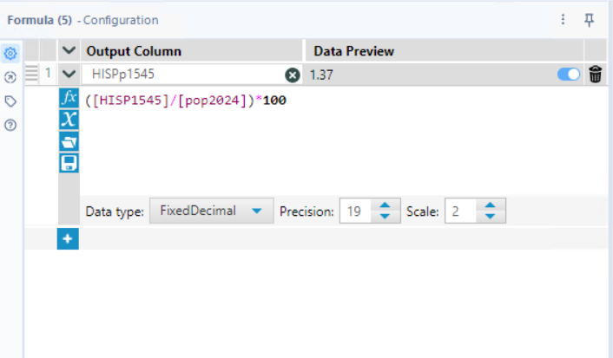

1. **US State to Target:**

I should target New Mexico; it has the strongest overall results. It has one of the highest percentages of Hispanic females aged 15–44 relative to the total population (10.29%), and a solid raw count of over 219,000 women in this group. While its spending on cosmetics/skincare products ($210.74) is moderate compared to some other states, the high concentration of my target user group makes it a strategic choice for outreach. Targeting New Mexico allows me to reach a dense, underserved population that could benefit from greater access to affordable and culturally relevant beauty and skincare resources.

